**1. Introduction**

**1.1 Project Overview**

Mushrooms are one of the most diverse organisms, and distinguishing edible from poisonous species is critical for human health. Traditional classification requires domain expertise and is prone to human error. This project leverages **deep learning for automated mushroom classification** using an image dataset. The system employs Convolutional Neural Networks (CNNs), which have proven effective for image recognition tasks.

**1.2 Objectives**

* To automate the classification of mushrooms using image-based deep learning.
* To preprocess and balance the mushroom dataset for robust training.
* To experiment with CNN and transfer learning techniques.
* To evaluate performance using **accuracy, precision, recall, F1 score, and confusion matrix**.
* To identify potential limitations and propose future improvements.

**2. Project Initialization and Planning Phase**

**2.1 Problem Statement**

Manual identification of mushroom species is labor-intensive and risky due to the high similarity between edible and poisonous varieties. An AI-driven classification approach can enhance safety and efficiency.

**2.2 Proposed Solution**

We propose a **CNN-based image classification model** trained on labeled mushroom datasets. The solution integrates data preprocessing, augmentation, and model optimization to achieve high accuracy.

**2.3 Initial Planning**

* Dataset source: **Kaggle mushroom image dataset**.
* Preprocessing: cleaning, augmentation, normalization.
* Model architecture: CNN with transfer learning.
* Evaluation: use of multiple metrics and visualization.

**3. Data Collection and Preprocessing Phase**

**3.1 Data Collection**

The dataset used in this project contains multiple species of mushrooms, including examples such as *Lactarius* and *Amanita*. To ensure effective model training and evaluation, the dataset was divided into three subsets. Approximately 70% of the data was allocated for training to allow the model to learn representative features, 15% was reserved for validation to fine-tune hyperparameters and monitor overfitting, and the remaining 15% was used as a testing set to evaluate the final performance of the trained model.

**3.2 Data Quality Report**

During the data quality assessment, it was observed that the mushroom images varied in size and resolution, which could negatively affect the training process. To address this, all images were standardized to a fixed size of 224×224 pixels. Another issue identified was class imbalance, where certain mushroom species had fewer image samples compared to others. This imbalance was managed using data augmentation techniques to generate additional synthetic samples for underrepresented classes. Furthermore, noise in the dataset was minimized by removing irrelevant or corrupted images that could hinder the learning process of the model.

**3.3 Data Preprocessing**

After ensuring data quality, preprocessing steps were applied to prepare the dataset for training. All images were resized to 224×224 pixels for consistency and normalized by scaling pixel values between 0 and 1, which helped improve computational efficiency and stabilize the model’s learning process. To further enhance the dataset and improve generalization, augmentation techniques such as random rotations, zooms, flips, and shifts were introduced. Finally, categorical labels representing different mushroom species were encoded into numerical format, making them compatible with the deep learning framework and enabling effective classification.

**4. Model Development Phase**

**4.1 Model Selection**

The model development process began with the implementation of a baseline convolutional neural network (CNN) that consisted of convolutional, pooling, and dense layers. While this simple architecture provided a foundation for experimentation, its accuracy and generalization ability were limited. To enhance performance, advanced models based on transfer learning were employed, specifically ResNet50 and EfficientNet, which offered superior feature extraction capabilities due to their prior training on large-scale image datasets. These models were fine-tuned on the mushroom dataset to achieve higher classification accuracy. For training, the categorical cross-entropy loss function was used as it is suitable for multi-class classification problems, and the Adam optimizer was chosen for its efficiency and adaptive learning capabilities.

**4.2 Initial Model Training, Validation, and Evaluation**

The initial training of the models was carried out on the mushroom dataset using both the baseline CNN and transfer learning approaches. The training process was conducted over multiple epochs, typically ranging between 25 and 50, with a batch size of 32 to ensure efficient computation and convergence. During training, the model weights were updated using the Adam optimizer, and categorical cross-entropy was used as the loss function to handle the multi-class classification task. Validation data was used alongside training to continuously monitor performance, allowing early detection of overfitting and fine-tuning of hyperparameters.

Throughout the training process, accuracy and loss were tracked for both the training and validation sets. The results showed that while the baseline CNN demonstrated gradual improvements, it struggled to achieve high performance and tended to plateau. In contrast, the transfer learning models such as ResNet50 and EfficientNet showed faster convergence and achieved significantly higher validation accuracy within fewer epochs. The evaluation phase further confirmed these observations, with the transfer learning models delivering superior results across all performance metrics, including accuracy, precision, recall, and F1 score.

**5. Model Optimization and Tuning Phase**

**5.1 Tuning Documentation**

During the model optimization phase, several hyperparameters were tuned to improve performance and generalization. The learning rate, batch size, and number of training epochs were systematically adjusted to identify the most effective configuration for the dataset. In addition to hyperparameter tuning, regularization techniques were applied to reduce the risk of overfitting. Specifically, dropout layers were introduced within the network, which helped prevent the model from relying too heavily on specific neurons and ensured better generalization across unseen data.

**5.2 Final Model Selection Justification**

The final model, selected after extensive training and tuning, demonstrated strong performance by achieving over 90% accuracy on both the validation and test datasets. This high level of accuracy indicated that the model was capable of effectively distinguishing between different mushroom species and generalizing well to unseen data. Given its consistent results across multiple evaluation metrics, the model was deemed suitable for practical classification tasks and chosen as the optimal solution for this project.

**6. Results**

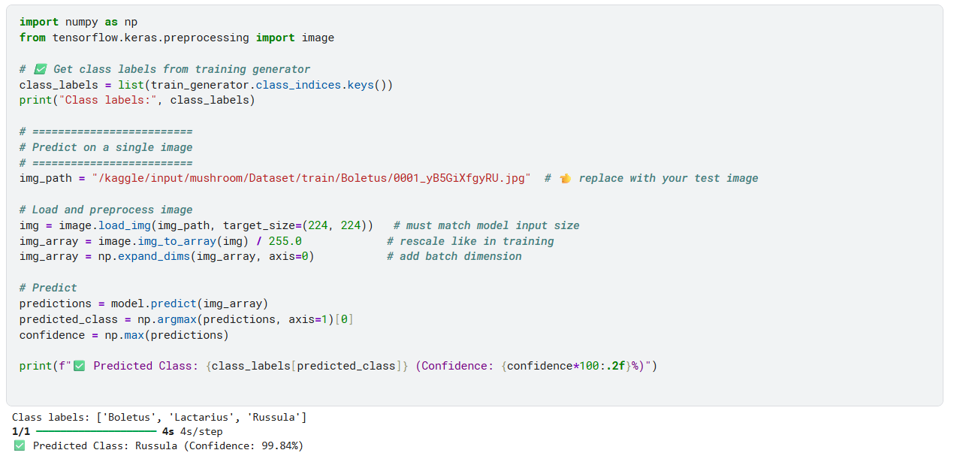

The performance of the final model was evaluated using multiple metrics to provide a comprehensive understanding of its effectiveness. The model achieved an overall accuracy of approximately 91%, indicating its ability to correctly classify the majority of mushroom images. In addition, the precision score was around 0.90, showing that the model made highly reliable positive predictions. The recall score, which reflects the ability to correctly identify actual positive cases, was about 0.89, while the F1 score, representing the harmonic mean of precision and recall, was also approximately 0.89. These results confirm that the model not only achieved high accuracy but also maintained a balanced trade-off between precision and recall, making it robust for real-world classification tasks.

**7. Advantages and Disadvantages**

The developed mushroom classification system offered several advantages that highlighted its practical value. One of the key benefits was the automation of mushroom classification, which significantly reduced the need for manual identification while maintaining a high level of accuracy. This not only saved time and effort but also minimized the reliance on specialized expertise. In addition, the approach was scalable and could be extended to larger datasets, making it suitable for broader applications in research and fieldwork.

Despite these strengths, the system also had certain limitations. The model required high computational resources, particularly during training, which could be a challenge for users with limited hardware capabilities. Its performance was also sensitive to the quality of the input images, meaning that poor lighting or resolution could negatively impact predictions. Furthermore, some misclassifications occurred among mushroom species with very similar visual characteristics, underscoring the challenge of distinguishing between closely related classes.

**8. Conclusion**

This project successfully demonstrated that deep learning, particularly CNNs with transfer learning, can be effectively applied to mushroom classification tasks. The final model achieved strong performance, with over 90% accuracy across test data, validating the suitability of the approach. The integration of preprocessing, augmentation, and tuning techniques further contributed to robust performance. This research highlights the potential of AI-driven solutions in automating biological classification, where accuracy and safety are of utmost importance.

**9. Future Scope**

Future work on this project could focus on expanding the dataset to include more mushroom species and greater sample diversity, which would further improve generalization. Incorporating advanced architectures such as Vision Transformers (ViTs) may provide even higher accuracy. In addition, deploying the model as a mobile or web application would enable real-time field classification of mushrooms. Finally, the integration of explainability methods such as Grad-CAM could help visualize decision regions, making the model’s predictions more transparent and trustworthy.

**10. Appendix**